

***Program: Computer Engineering and Software Systems***

***Course Code: CSE232***

***Course Name: Advanced Software Engineering***

***Course Instructor:***

**Dr. Gamal A. Ebrahim**

**Project Name:**

**University Information System**

**Submitted By:**

**Ilaria Refaat Ghobrial 18P3050**

**Khaled Medhat Mahmoud 18P3557**

**Hana Yasser Amged 18P5007**

**Mohamed Magdy Mostafa 18P5160**

**Osama Alaa Shoukry 18P5205**

**Omar Mohamed Lotfy 18P5606**

**Laila Mohamed Aborizka 18P9654**

**AIN SHAMS UNIVERSITY**

**FACULTY OF ENGINEERING**

# Abstract:

Managing universities thought traditional pen and paper is unadmired nowadays it is inefficient, and it allows for mistakes.

That is why the University information system is essential to every university due to its wide variety of useful options that facilitates many aspects of managing the university from student admission, registration and grading to set up schedules for students and staff.

Table of Contents

Abstract: 2

1 Introduction: 6

1.1 Purpose: 6

1.2 List of definitions: 6

1.3 Scope: 6

1.4 Overview: 6

2 General description: 6

2.1 Product perspective: 6

2.2 General capabilities: 7

2.3 General constraints: 7

2.4 User characteristics: 7

2.5 Environment description: 7

2.6 Assumptions and dependencies: 7

3 Specific Requirements: 8

3.1 Functional requirements: 8

3.2 Non-functional requirements: 8

4 Use-Case Diagram and the Narrative Description of all use cases: 9

4.1 9

4.2 Use-Case Description: 9

5 Swimlane Diagrams of all use cases 15

6 Interaction Diagrams 17

7 Noun Extraction and CRC Cards 19

7.1 Noun Extraction first iteration: 19

7.2 CRC Cards 19

8 Class Diagram 20

9 State Diagram 20

10 Client-Object Relation 24

11 OOAD Methodologies 25

11.1 Analysis Phase: 25

11.1.1 Object model 25

11.1.2 Dynamic model 25

11.1.3 Functional model 25

11.2 System design 30

11.3 Object design 30

11.4 Implementation 30

11.4.1 Second Methodology: Booch methodology 30

11.4.2 Third Methodology: Jacobson et al. Methodologies 32

12 Comparative Analysis of the Output of the Adopted Methodologies 32

12.1 Booch Methodology 32

12.1.1 Advantages: 32

12.1.2 Disadvantages: 33

12.2 OMT Methodology 33

12.2.1 Advantages: 34

12.2.2 Disadvantages: 34

12.3 Jacobson et al. Methodology 34

12.3.1 Advantages: 35

12.3.2 Disadvantages: 35

13 Architectural Model 35

13.1 Abstract-data-types-style: 35

14 Component Diagram 36

15 Testing 36

15.1 Class testing: 36

15.2 Integration testing: 37

15.3 System testing: 38

16 Time Plan 38

16.1 Summary: 40

17 User Guide 41

18 Appendices 45

List of Figures & Tables:

Figure 1: Use-Case Diagram 8

Figure 2: Swimlane Diagram 14

Figure 3: Activity Diagram 15

Figure 4: Doctor Sequence Diagram 16

Figure 5: Student Affairs Sequence Diagram 17

Figure 6: CRC Cards 18

Figure 7: Class Diagram 19

Figure 8: Login State Diagram 19

Figure 9: Registration State Diagram 20

Figure 10: Class Allocation State Diagram 20

Figure 11: Admission State Diagram 21

Figure 12: Manage Schedule State Diagram 21

Figure 13: Grading State Diagram 22

Figure 14: Client-Object Relation Diagram 23

Figure 15: DFD Level (0) 25

Figure 16: DFD level (1) 25

Figure 17: DFD level (2.1) 26

Figure 18:DFD level (2.2) 26

Figure 19: DFD level (2.3) 27

Figure 20: DFD level (2.4) 27

Figure 21: DFD level (2.5) 28

Figure 22: DFD level (2.6) 28

Figure 23: Component Diagram 35

Figure 24: Login Form 40

Figure 25: Login Form with Error 40

Figure 26: Doctor HomePage 41

Figure 27: Student Affairs HomePage 41

Figure 28: Grading GUI 42

Figure 29: Registration GUI 42

Figure 30: Admission GUI 43

Figure 31: Major Selection in Class Allocation 43

Figure 32: Level Selection in Class Allocation 44

Figure 33: Class Allocation GUI 44

Table 1: Time Plan Table 38

# Introduction:

## Purpose:

This document summarizes up the whole project and describes the project in different forms of diagrams (activity diagram, component diagram, etc...), this document is also used by the developers to keep track of the development process and to remember what decisions they took and why they took them.

## List of definitions:

???

## Scope:

The product is University information system where there are two main users:

Doctor and Student Affairs where each of them can login to the system.

The Doctor can confirm registration form of the students and assign grades of the courses to the students.

And the Student Affairs can confirm the admission form of the requesting students and, he is able to set the schedule of the staff, exam and student.

## Overview:

???

# General description:



## Product perspective:

The product will be a desktop software for university that facilitates management of services concerned with doctors and student affairs. This system interacts with students’ Moodle.

## General capabilities:

* System allows doctors to Validate registration.
* System allows doctors to assign grades.
* System allows student affairs to manage class, student and exams’ schedule.
* System allows student affairs to Allocate classrooms.
* System allows student affairs to Validate admission.
* Not all the features of the system should operate properly for all users, system differentiate between users based on their IDS.

## General constraints:

The System should have fast response time, so it should run on PCS with high processors, and should be supported with high-speed network.

## User characteristics:

* Doctors: Validate registration, assign grades
* Student affairs: manage class, student and exams’ schedule, allocate classrooms, Validate admission.

## Environment description:

* Desktop application.
* Language used is C++.
* Needs an operating system.
* Needs internet connection to interact with students’ Moodle.
* Data base to store students’ affair and doctors’ passwords and IDS and to store students and courses data.

## Assumptions and dependencies:

* Doctor is only allowed to register courses for students and to grade them, while student’s affairs member is allowed to create or edit exams schedule, staff schedule and student schedule, also to allocate classes for students and to access university admission requests.
* System budget is less than n document.
* System should follow ministry of higher education and scientific research laws.
* The System should have fast response time, so it should run on PCS with high processors, and should be supported with high-speed network.
* System should be updated after each semester.

# Specific Requirements:

## Functional requirements:

* Validate registration.
* Assign grades.
* Manage class schedules.
* Manage exams schedule.
* Manage staff schedule.
* Allocate classrooms.
* Validate admission.

## Non-functional requirements:

* High protection.
* The system should comply with all local and international laws that apply.
* It should have fast response time.
* High speed network.
* Standard safety measures should be compatible with the framework.
* Multiuser System: in the same environment, the system must be able to recognize the existence of more than one user.
* Not All the features of the system should operate properly for all users, concerning high level of protection.

# Use-Case Diagram and the Narrative Description of all use cases:



Use-Case Diagram:

## 

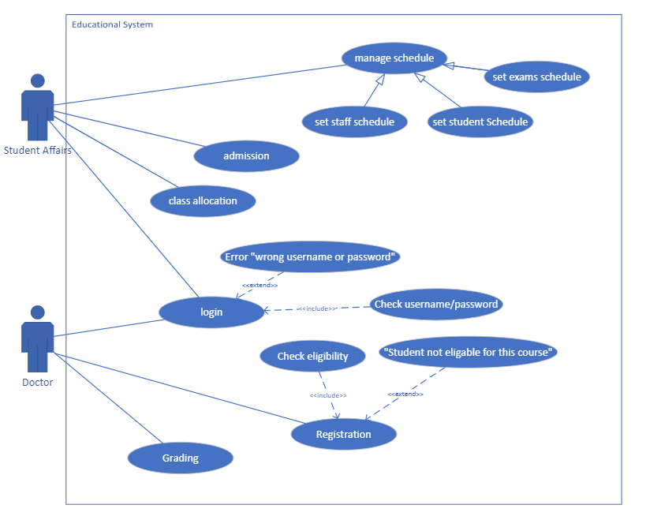

#### Figure 1: Use-Case Diagram

## Use-Case Description:

Use-Case 1:

|  |  |
| --- | --- |
| Use case name | Login |
| Goal in Context | User Logs in to the system |
| Preconditions | User already has an account |
| Successful End Condition | User successfully logs in to the system |
| Failed End Condition | User fails to log in to the system |
| Primary Actors | Doctor, Student Affairs |
| Included Use-Case | Check Username / password |

|  |  |  |
| --- | --- | --- |
| Main Flow | Step | Action |
|  | 1 | User asks the system to log in |
|  | 2 | User enter credentials |
|  | 3 Include::Check Username  /password | User’s credentials are checked |
|  | 4 | User is redirected to the specified homepage |

|  |  |  |
| --- | --- | --- |
| Extensions | Step | Action |
|  | 3.1 | User’s credentials are not verified |
|  | 3.2 | System returns an error message. “wrong username or password” |

Use-Case 2:

|  |  |
| --- | --- |
| Use case name | Registration |
| Goal in Context | Doctor adds student to the course successfully |
| Preconditions | Student requests taking the course |
| Successful End Condition | Student is successfully registered to the course |
| Failed End Condition | Student is not registered to the course |
| Primary Actors | Doctor |
| Included Use-Case | Check Eligibility |

|  |  |  |
| --- | --- | --- |
| Main Flow | Step | Action |
|  | 1 | View registration request |
|  | 2  Include::  Check Eligibility | Student’s eligibility is checked |
|  | 3 | Show that student is eligible to register for this course |
|  | 4 | Doctor accepts registration request |
|  | 5 | Doctor adds student’s name to the course |

|  |  |  |
| --- | --- | --- |
| Extensions | Step | Action |
|  | 2.1 | Show that student is not eligible to register for this course |
|  | 2.2 | Doctor declines registration request |

Use-Case 3:

|  |  |
| --- | --- |
| Use case name | Grading |
| Goal in Context | Doctor Successfully grades the students |
| Preconditions | Student is enlisted in the course |
| Successful End Condition | Doctor successfully grades the student |
| Failed End Condition | Doctor fails to grade the student |
| Primary Actors | Doctor |

|  |  |  |
| --- | --- | --- |
| Main Flow | Step | Action |
|  | 1 | Doctor creates an evaluation form |
|  | 2 | System shows enlisted students |
|  | 3 | Doctor adds students’ grades across the semester to the form |
|  | 4 | System shows the total marks that each student has |
|  | 5 | System calculates each students’ grade |

Use-Case 4:

|  |  |
| --- | --- |
| Use case name | Admission |
| Goal in Context | Student Affairs admits the student to the university |
| Preconditions | Student has requested admission |
| Successful End Condition | Student file is successfully created in the database |
| Failed End Condition | Student’s file is not created in the database |
| Primary Actors | Student Affairs |
| Included Use-Case | Check Admission Requirements |

|  |  |  |
| --- | --- | --- |
| Main Flow | Step | Action |
|  | 1 | View admission request |
|  | 2  Include::Check  Admission  Requirements | Check if the student meets the requirements |
|  | 3 | Accept student into the university |
|  | 4 | Student’s file is created in the database |

|  |  |  |
| --- | --- | --- |
| Extensions | Step | Action |
|  | 2.1 | Student does not meet the requirements |
|  | 2.2 | Student is not accepted into the university |

Use-Case 5:

|  |  |
| --- | --- |
| Use case name | Class Allocation |
| Goal in Context | Student Affairs organizes students in groups |
| Preconditions | Student is registered to courses |
| Successful End Condition | Students are organized in groups and sections |
| Failed End Condition | Students are not organized in groups and sections |
| Primary Actors | Student Affairs |

|  |  |  |
| --- | --- | --- |
| Main Flow | Step | Action |
|  | 1 | Show all major, level |
|  | 2 | Select a major, level |
|  | 3 | Show students |
|  | 4 | Generate number of groups, sections |
|  | 5 | Assign students to groups, sections |

Use-Case 6:

|  |  |
| --- | --- |
| Use case name | Exams Schedule |
| Goal in Context | Student Affairs generate exam schedule |
| Preconditions | Course is ongoing |
| Successful End Condition | Exam schedule is generated |
| Failed End Condition | Exam schedule is not generated |
| Primary Actors | Student Affairs |

|  |  |  |
| --- | --- | --- |
| Main Flow | Step | Action |
|  | 1 | Show available halls |
|  | 2 | Choose course |
|  | 3 | Show available days |
|  | 4 | Reserve halls at the given time for the selected course |
|  | 5 | Combine all schedules into one |

Use-Case 7:

|  |  |
| --- | --- |
| Use case name | Student Schedule |
| Goal in Context | Student Affairs generate student schedule |
| Preconditions | All group members are enlisted in the same courses |
| Successful End Condition | Student schedule is generated successfully |
| Failed End Condition | Student schedule fails to generate |
| Primary Actors | Student Affairs |

|  |  |  |
| --- | --- | --- |
| Main Flow | Step | Action |
|  | 1 | Student Affairs select major |
|  | 2 | Select level |
|  | 3 | Select group |
|  | 4 | Show available halls |
|  | 5 | Select halls |
|  | 6 | Generate schedule |

Use-Case 8:

|  |  |
| --- | --- |
| Use case name | Staff Schedule |
| Goal in Context | Student Affairs generate staff schedule |
| Preconditions | Doctor does not teach more than 3 courses |
| Successful End Condition | Staff schedule is generated |
| Failed End Condition | Staff schedule fails to generate |
| Primary Actors | Student Affairs |

|  |  |  |
| --- | --- | --- |
| Main Flow | Step | Action |
|  | 1 | Student Affairs view all doctors |
|  | 2 | Student Affairs select doctor |
|  | 3 | Show doctor’s courses |
|  | 4 | Select a course |
|  | 5 | Show available periods for doctor |
|  | 6 | Select group |
|  | 7 | Generate schedule |

# Swimlane Diagrams of all use cases

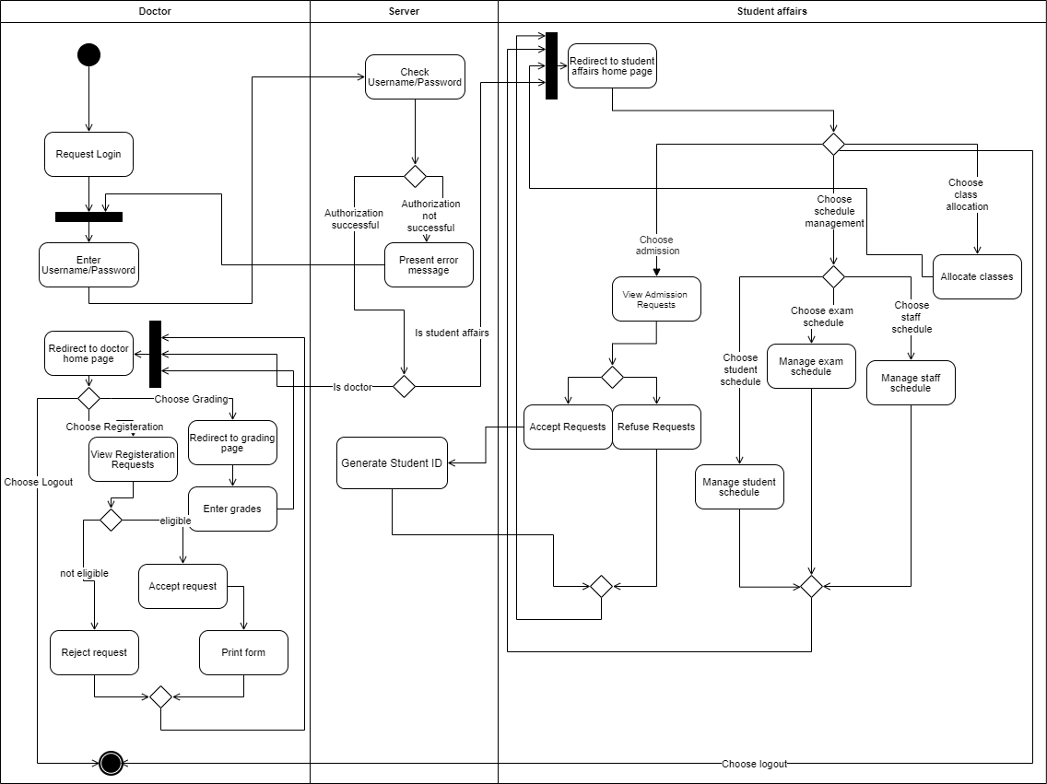

#### Figure 2: Swimlane Diagram

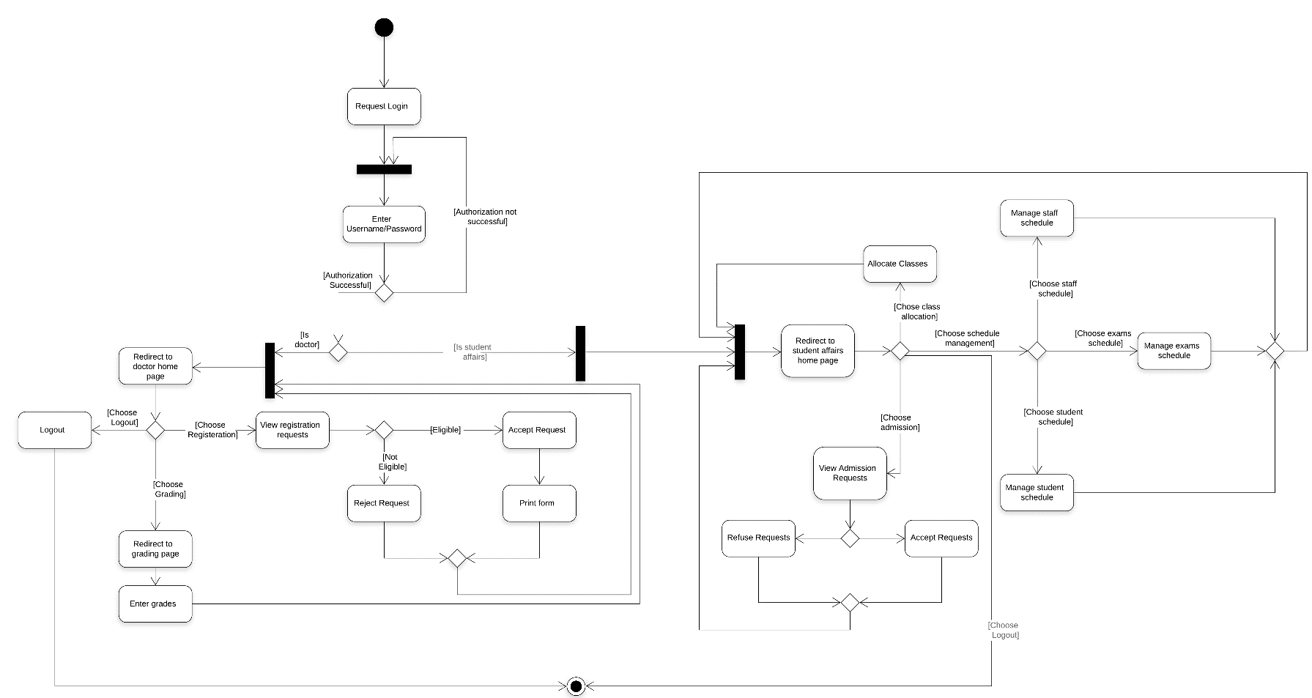

#### Figure 3: Activity Diagram

# Interaction Diagrams

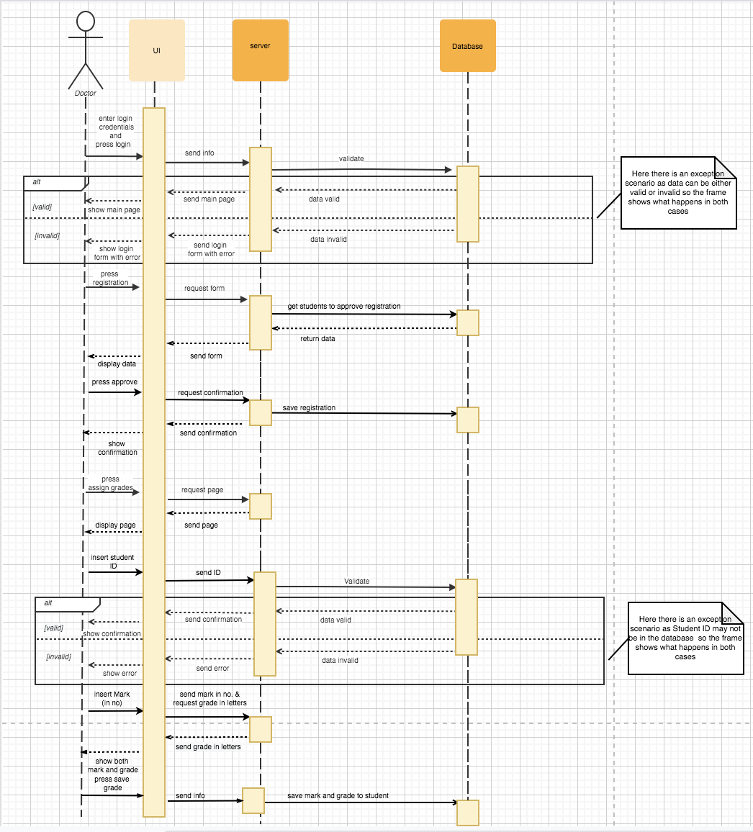The sequence diagram is divided into two diagrams: Doctor and Student Affairs

#### Figure 4: Doctor Sequence Diagram

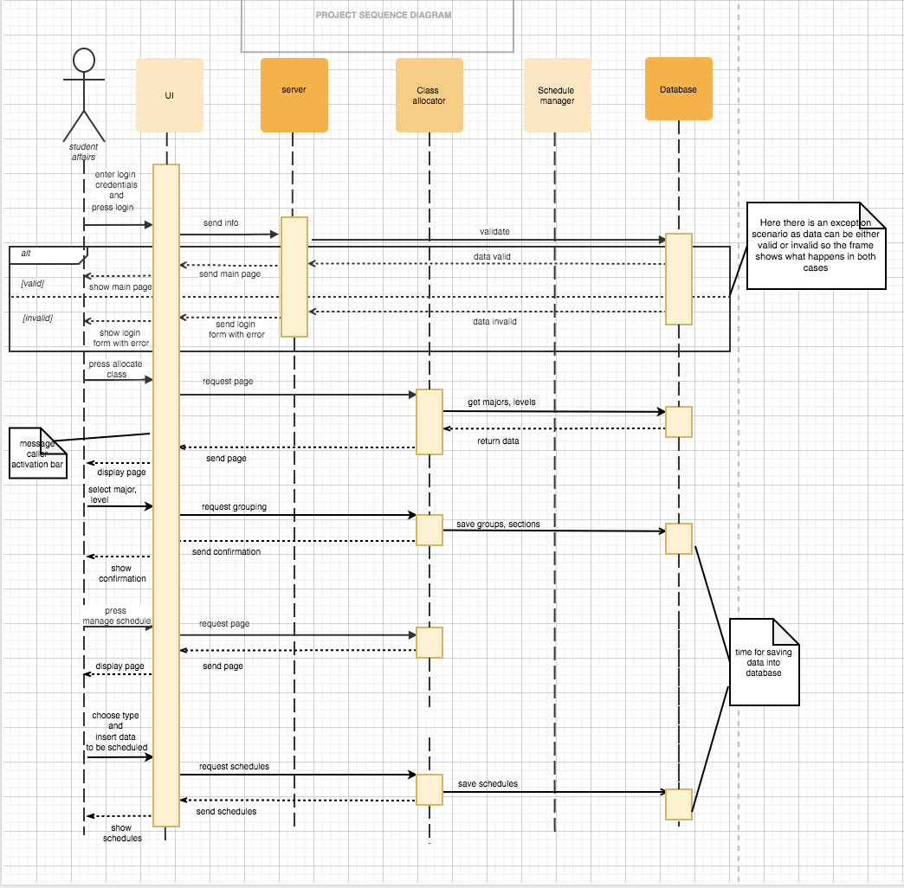

#### Figure 5: Student Affairs Sequence Diagram

# Noun Extraction and CRC Cards

## Noun Extraction first iteration:

Universities, systems, management, services, registration, grading, class schedule management, exam schedule management, library, staff schedule management, classroom allocation.

Second iteration (removing abstract terms):

Management, registration, grading, schedule management, class allocation.

## CRC Cards

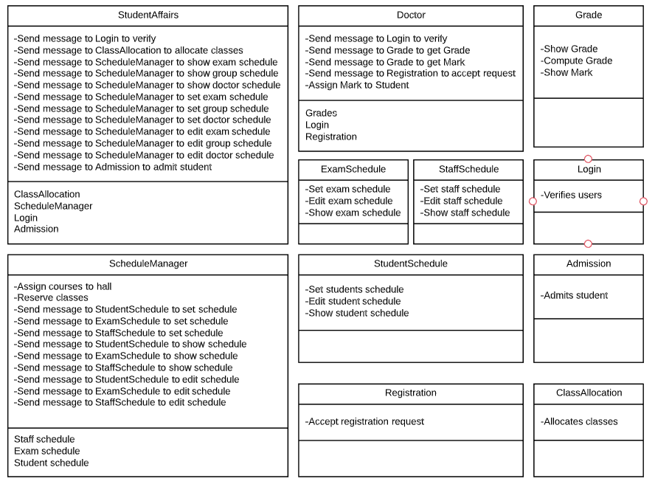

#### Figure 6: CRC Cards

# Class Diagram

#### Figure 7: Class Diagram

# State Diagram

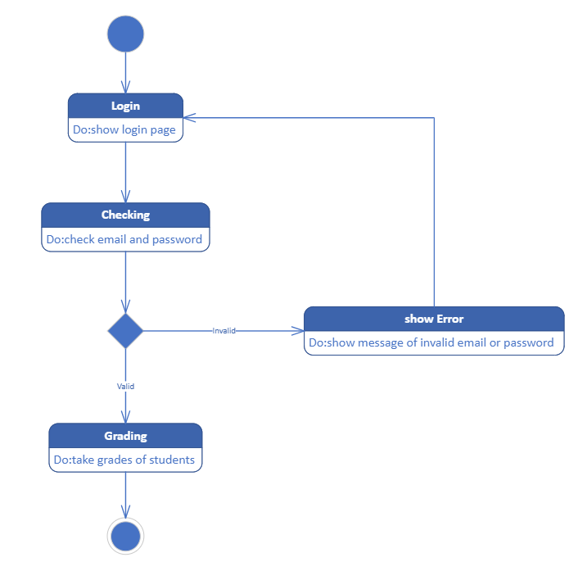

#### Figure 8: Login State Diagram

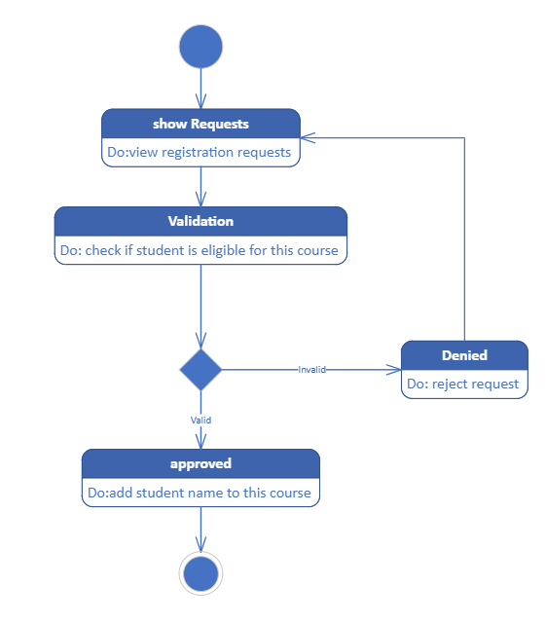

#### Figure 9: Registration State Diagram

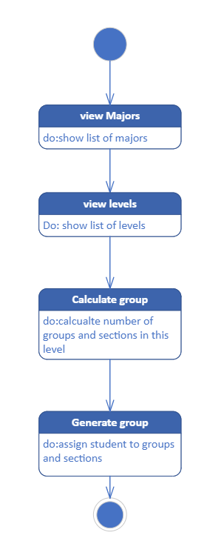

#### Figure 10: Class Allocation State Diagram

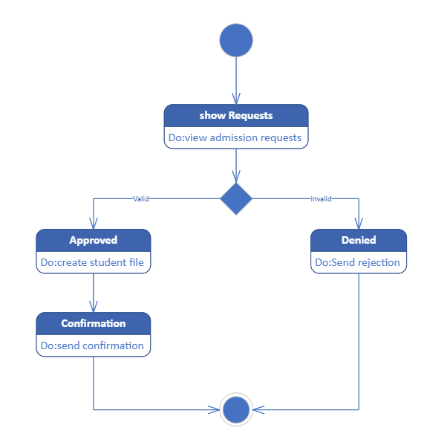

#### Figure 11: Admission State Diagram

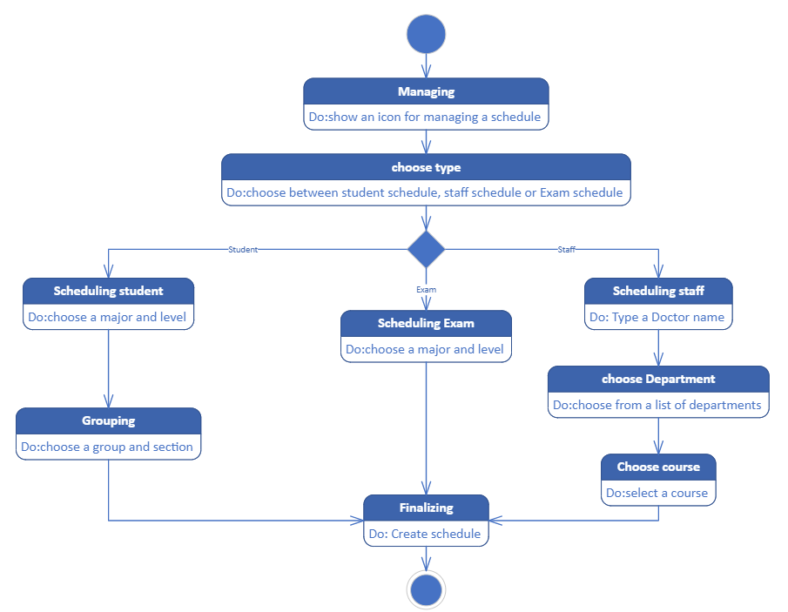

#### Figure 12: Manage Schedule State Diagram

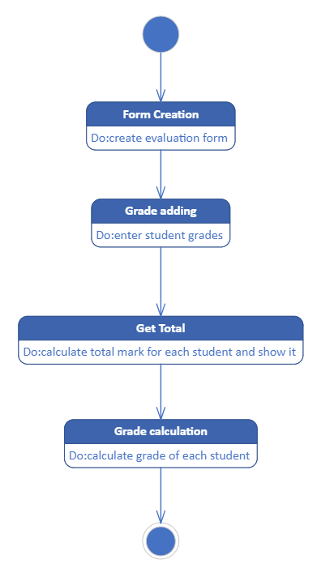

#### Figure 13: Grading State Diagram

# Client-Object Relation

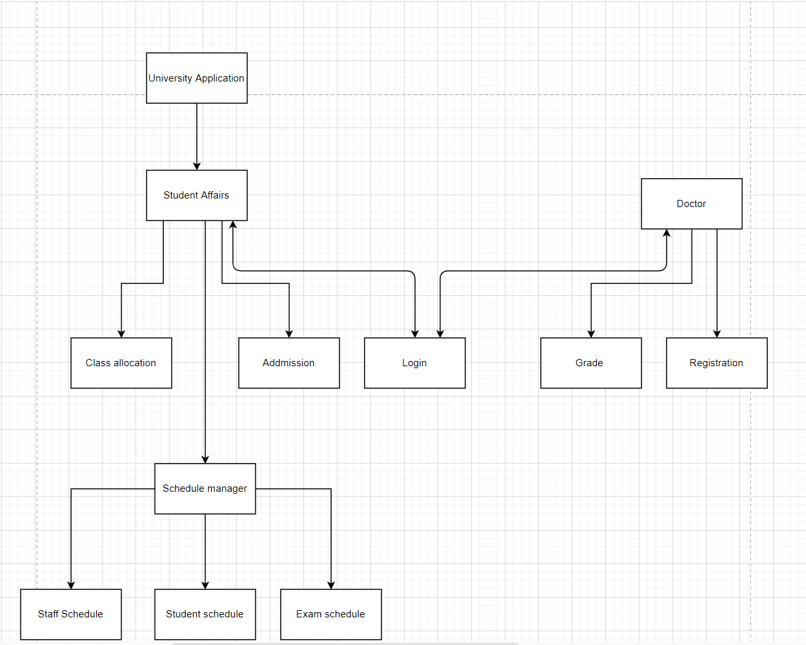

#### Figure 14: Client-Object Relation Diagram

# OOAD Methodologies

First Methodology: Rumbaugh et. al.’s Object Modeling Technique (OMT)

This technique includes four phases, which are usually performed iteratively:

## Analysis Phase:

This phase is divided into 3 three distinct parts:

### Object model

presented by the object model (class diagram) fig.6 and the data dictionary.

### Dynamic model

introduce by the state diagrams or an event flow diagrams as in state diagram and sequence diagram

### Functional model

Functional Model in OMT traces the whole processes and actions using a data flow diagram (DFD). It focuses on how data is flowing, where data is stored and how it is processed by different processes.

DFD diagram:

1. Context diagram:

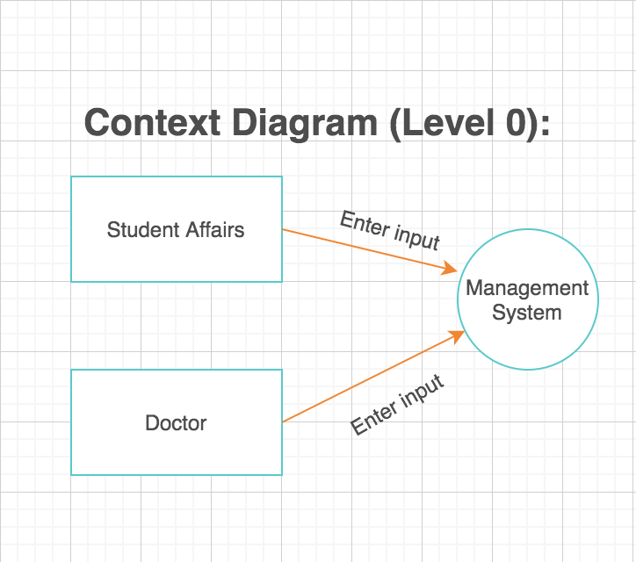

#### Figure 15: DFD Level (0)

1. DFD level 1:

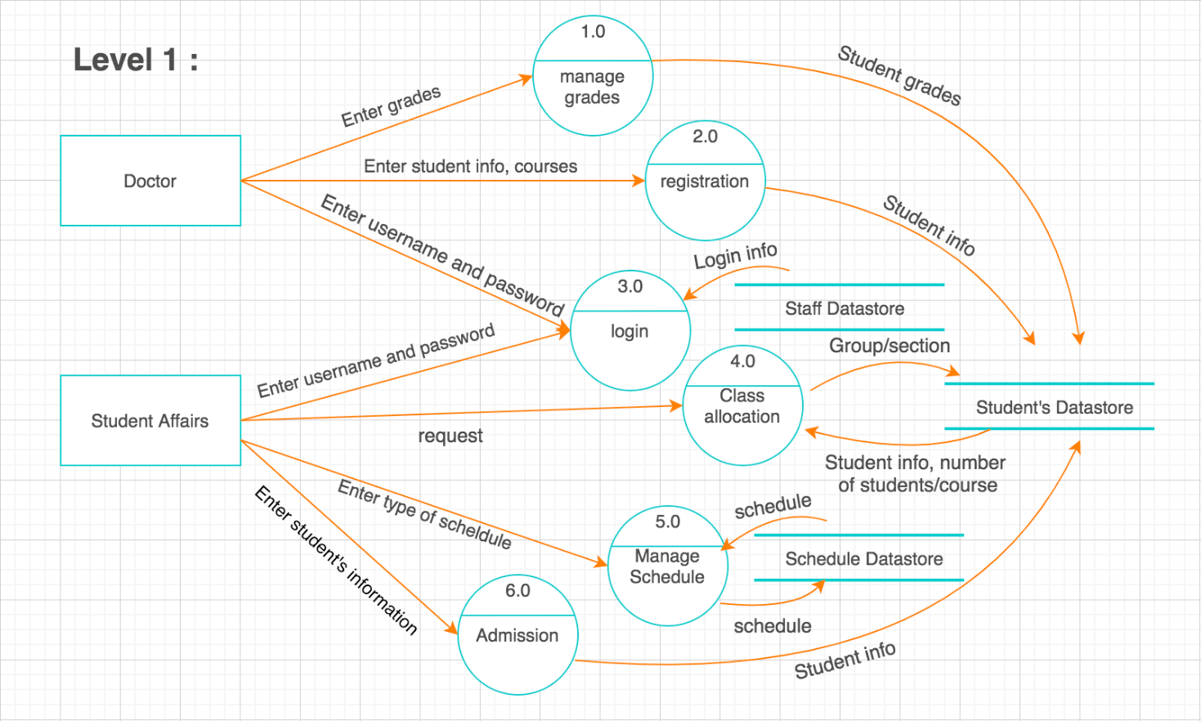

#### Figure 16: DFD level (1)

1. DFD level 2:

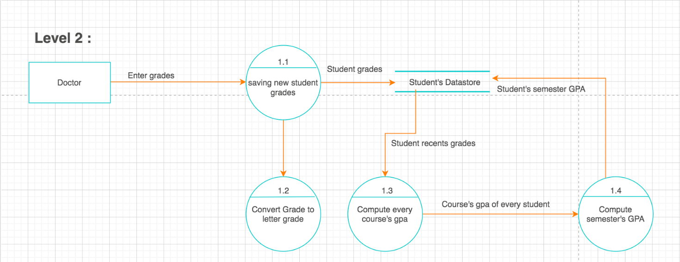

#### Figure 17: DFD level (2.1)

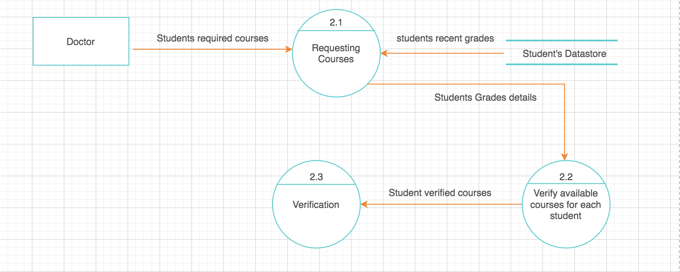

#### Figure 18:DFD level (2.2)

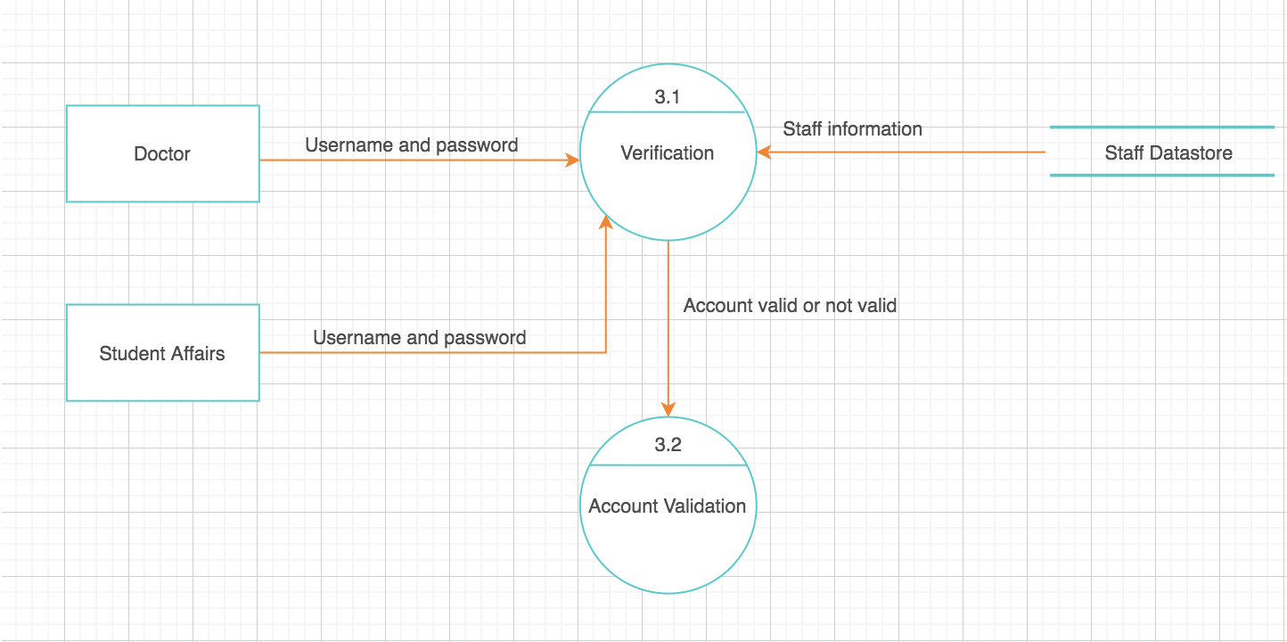

#### Figure 19: DFD level (2.3)

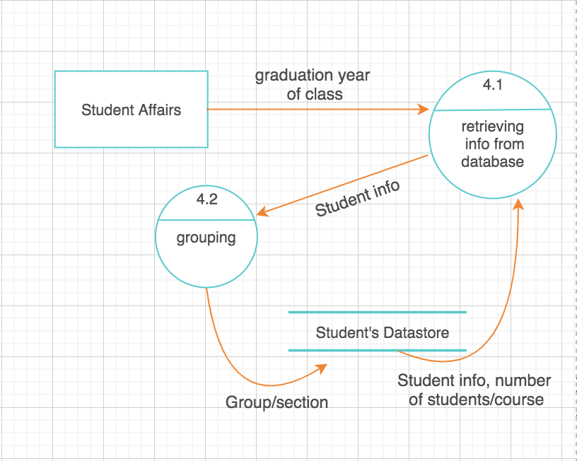

#### Figure 20: DFD level (2.4)

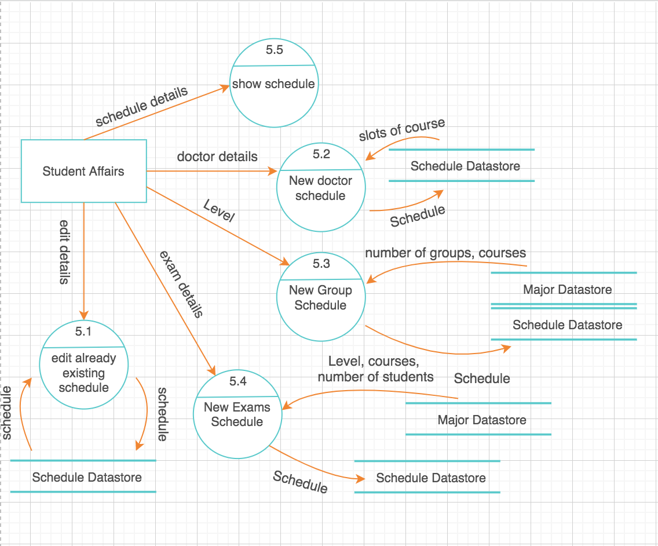

#### Figure 21: DFD level (2.5)

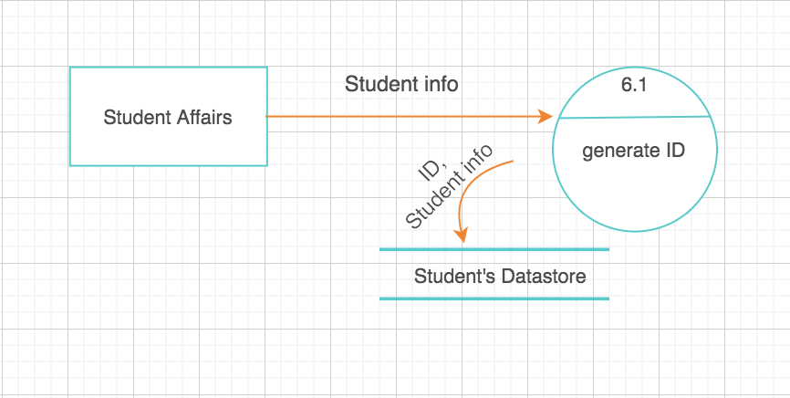

#### Figure 22: DFD level (2.6)

## System design

In this phase subsystems, concurrent tasks, and data storage are used to evaluate the architectural system. The high-level structure of the system is engineered during system design. During the system design phase, the decisions that are made are: The system is divided into sub-systems that are then delegated into processes and tasks, taking into account concurrency and collaboration. In order to manage shared or global information, data storage is fixed along with a strategy. Boundary scenarios are tested to help guide communication priorities.

## Object design

The object design phase follows the system design phase. The implementation plan is established here. Object design is responsible for classifying the current and remaining classes, their relations, their attributes, and appropriate operations to introduce a solution to the problem. In object design: Along with any object necessary for implementation, operations and data structures are completely determined. Association at the class level are determined. Classes relations like inheritance, aggregation, association, and default values are also checked.

## Implementation

The OMT implementation process is the translation of the concept into constructs in the programming language. Good software engineering practice is important so that the design phase is easily converted into the phase of implementation. Thus, all constructs should be considered for the following noteworthy points: increasing flexibility, making amendments easier for the design traceability, increasing efficiency.

### Second Methodology: Booch methodology

The Booch methodology is divided into:

* A macro development process.
* A micro development process.

The macro process identifies the following activities cycle:

* Conceptualization: establishing core requirements

Specific requirements

* Analysis and Development of the model: We use the class diagram in this phase to define the roles and responsibilities objects play in the performance of the system’s desired requirements. Then, for each example, we use the object diagram or interactions diagrams to define the system’s desired scenarios.

???

* Design or create the system architecture: In the design phase, we use the class diagram to determine what classes should be implemented & the relation between them. Next, we use the object diagram to determine the techniques used to regulate the collaboration of objects. Then, to map out where each class and object should be declared, we use the module diagram. Finally, to decide which process to assign a task, we use the process diagram.

???

* Evolution: for the implementation
* Maintenance : for evolution after delivery

New classes, structures or behaviors that emerges during the macro process are added to the micro.

* Process. The following cycles are included in it:
* Identifying classes and objects
* Identifying their semantics
* Identifying their relationships
* Specifying their interfaces and implementation

Which is clear at fig.6

### Third Methodology: Jacobson et al. Methodologies

In this methodology analysis contains Use cases

Use cases usually helps to better understand the system’s requirements. A use case represents the connection between users and a system. The use-case model expresses the goal and the responsibility of the system to its users as in fig.1

# Comparative Analysis of the Output of the Adopted Methodologies



## Booch Methodology

The Booch methodology uses the processes that follow: Identification of the objects, Identification of object’s semantics, Identifying of the relationships and lastly implementation and iteration.

Identification of the objects is the step in which the key abstractions are found in the problem domain and the first set of attributes and classes. In the identification of the semantics step, the developer needs to reach a decision about how to organize the classes’ behavior (the methods) as well as the interaction that occurs between the classes and their objects (specification of behavior). During these the state transition diagrams are used in order to model the object’s states. The behavior specification is modelled with the use of timing diagrams, in conjunction with object diagrams. During the relationships’ identification step both the static as well as the dynamic relationships are modelled. The relationships being covered are uses, inherits, instantiates and meta-class for classes and for objects they are association as well as aggregation relationships.

### Advantages:

The Booch methodology is a very accurate method and this allows it to stand out among the other OOAD methodologies. The Booch methodology allows the engineers working on the analysis and design part of the project to have a very detailed understanding of the project due to how it breaks the steps of design into multiple easily carried out steps which allows for a better overall final product for the entire project.

### Disadvantages:

The Booch methodology however is not perfect and can be improved upon and as such it has some problems of its own. The Booch methodology is very accurate but that comes at the cost of it being extremely complex and this causes it to be impossible to draw it by hand. The Booch methodology also uses multiple different types of diagrams in order to be as accurate as possible but this causes the problem of a possible risk of losing information due to it being fragmented across diagrams.

## OMT Methodology

The OMT method is comprised of just three models, the object model, the functional model and the dynamic model. The object model is involved with the description of classes and objects, their attributes, methods as well as relationships. Relationships include association, inheritance and aggregation. The development of the object model involves the following: The identification of objects as well as classes, Preparation of a dictionary of data, Identification of aggregation as well as association relationships, Identification of classes and objects attributes, Organization of the classes in terms of inheritance, the Verification of access paths, the refinement and iteration of the model and lastly, the classes are grouped together into modules.

Concerning the identification of classes, behaviors as well as attributes OMT method carries out certain steps for every single identification. Identifying relationships is done by identifying each and every one such that it is carried out by identifying association and then aggregation among others and then organizing the result and simplifying as much as possible. Other relationships that are identified in this method are instantiation as well as meta-class. OMT does not necessarily report on the assignment of classes, attributes as well as behaviors. However, this is addressed in an informal way in the organize step as well as the simplification if classes.

### Advantages:

The OMT methodology can also be said to be extremely accurate although not as accurate as the Booch method tend to be. The edge it has over the Booch method is that it can be considered relatively simple and as such could be hand drawn and this allows for a lot of versatility in its design as well as in communication between the team working on the project.

### Disadvantages:

The OMT has a rather glaring weakness and this is that it lacks a method or a mechanism to find out issues in real time as it has times of tests and doesn’t test every step done once it is done as such you could end up a very big problem that was started with a relatively simple issue, but it wasn’t caught when it happened. It also doesn’t have time constrains mechanism, and lastly it shares the same weakness with the Booch method which is that it can be fragmented across multiple diagrams due to the fact that it uses multiple diagrams.

## Jacobson et al. Methodology

It is the methodology that started the use of the use case diagrams in the object-oriented analysis and design field, it involved having a great understanding of the system requirements and showing the interaction between the system and the user. The use case is predicated on writing a detailed description of every single instance of a use case on the design. The use case description is used to define how begins and ends as well as when it begins and ends. It shows the interaction between use case and the actors that are associated with it, this includes what is being exchanged between them in terms of data and when that happens. It also shows when the use case would require data that is stored in the system’s data base as well as how it is going to use it. It shows if there is an exception to the flow of events of the diagram and lastly it shows the method as well as the time at which the issues and problems that occur within the use case are handled.

### Advantages:

The Jacobson et al. methodology is a rather simple overall methodology and as such it is a very versatile one and makes it very popular among design engineers that are just starting out and it also makes it very easy for the clients and the stockholders to understand the workings of it and increases communication efficiency and could result in a product that is very much to the client’s liking.

### Disadvantages:

The Jacobson et al. methodology is as mentioned above very simple and although this has its advantages it also poses some problems to designing team. The fact that it is simple results in it not being that accurate and missing a lot of the information and would need the help of another method to be implemented alongside it in order to show all the information that need to be shown.

# Architectural Model

## Abstract-data-types-style:

Problem: some information needs to be protected (grades, scheduling data).

Context: OO-language (Java) which provide the class concept.

Solution:

* System model: grades and scheduling have their own local data.
* Grades: Doctor, Scheduling: Student affairs
* Connectors: System call
* Control structure: Single thread

Variants: caused by language facilities.

Justification:

The data pertaining to grades must be very secure and can only be accessed by the doctor responsible for it as it is very important.

Same can be said about the scheduling such that it must not be accessed by anyone other than the student affairs staff tasked with it.

# Component Diagram

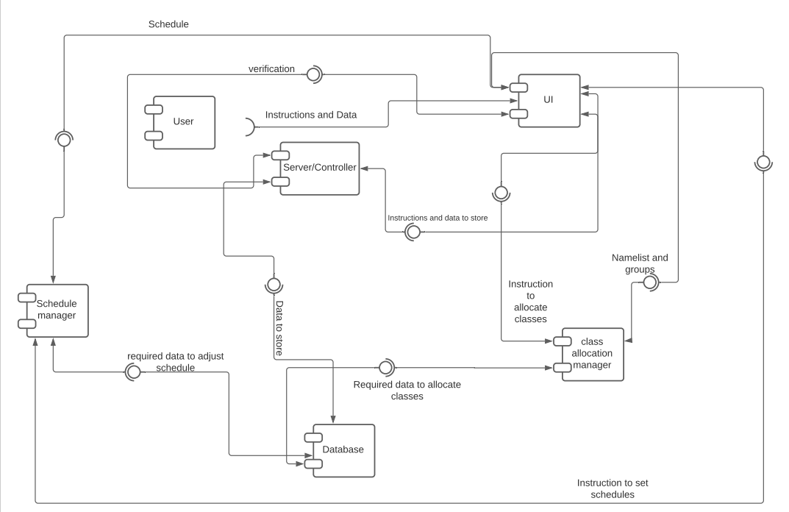

#### Figure 23: Component Diagram

# Testing

## Class testing:

System will be divided into modules where each one will be tested and will be supported by a stub and driver modules if needed. Tested class will be provided by some functions outputs from the stub module.

Class Doctor is tested by calling function AssignGrade() with grades taken from the stub module. Some global variables such as StudentID will be provided by the driver, where each grade should be assigned to the correct ID.

Class ScheduleManager will be tested using ShowSchedule() function called by class StudentAffairs where we should confirm that there is no overlapping between classes periods or halls.

Class StudentAffairs is tested by calling ClassAllocation() function that takes major and level info from stub module where each level is divided into majors and each major is divided into number of groups and based on these groups classes are allocated so we should confirm that there is no interference between majors’ classes.

Class Grade is tested by calling computeGrade(Mark:float) that takes Mark as input from a driver , and then we see if it gives the required output ( calculations are right).this function is called by class Doctor.

Class ClassAllocation is tested by calling allocateclasse(major:string,level:string) that takes major and level as inputs from the driver where students should be assigned to classes based on their level an major , so this function is tested by confirming that each student is assigned to only one class.

Class StudentSchedule is tested by calling function ShowSchedule() that calls function SetSchedule(Group:int,Section:int,Major:String,Level:String) , we should confirm that there is no overlapping between classes periods and that courses are related to the right major ,level and section.

## Integration testing:

This is a top-bottom test and as shown in class testing, we needed more stubs then drivers to test these classes. Class Doctor and Grade work together and as shown class Doctor calls the function computeGrade() that at some point was a stub to doctor that provides him with Marks so that he could assign it using AssignGrade().

Class StudentAffairs is responsible of managing schedules so it works with ClassAllocation where StudentAffairs is tested by calling ClassAllocation() using outputs of allocateclasse(major:string,level:string) and by using ScheduleManager it creates different kinds of schedule mainly here StudentSchedule and ExamSchedule.

Class Login, StudentAffairs and Doctor are working together where the system should differentiate between users by giving each of them an account so that user can access system after getting a validation from verify(username:string,password:string).

## System testing:

Alpha testing: After completing and assembling the whole system, a test is done to handle all bugs or problems that could face any user.

Security testing: A security test is done to make sure that Doctors and student affairs data are hidden.

Stress testing: if many users access at the same time like many doctors are uploading grades at the same time or registration time where student affairs employees and doctors access at the same time to manage admission and registration. System undergo this test to confirm its high performance, server’s reliability and the responsiveness of the network.

# Time Plan

#### Table 1: Time Plan Table

|  |  |  |  |  |  |  |  |  |  |
| --- | --- | --- | --- | --- | --- | --- | --- | --- | --- |
| Tasks | Start | Total effort | Week 1  8/11 | Week 2  15/11 | Week 3  22/11 | Week 4  29/11 | Week 5  6/12 | Week 6  13/12 | Week 7  20/12 |
| Specific Requirements | 8/11 | 1 hour |  |  |  |  |  |  |  |
| Use-Case Diagram and the Narrative Description of all use cases | 8/11 | 3 hours |  |  |  |  |  |  |  |
| Swimlane Diagrams of all use cases | 8/11 | 1 hour |  |  |  |  |  |  |  |
| Interaction Diagrams | 8/11 | 1 hour |  |  |  |  |  |  |  |
| Noun Extraction and CRC Cards | 15/11 | 1 hour |  |  |  |  |  |  |  |
| Class Diagram | 15/11 | 4 hours |  |  |  |  |  |  |  |
| State Diagram | 8/11 | 1 hour |  |  |  |  |  |  |  |
| Client-Object Relation Diagram | 29/11 | ½ hour |  |  |  |  |  |  |  |
| OOAD Method-ologies | 29/11 | 3 hours |  |  |  |  |  |  |  |
| Comparative Analysis of the Output of the Adopted Method-ologies | 6/12 | 2 hours |  |  |  |  |  |  |  |
| Architectural Model | 29/11 | 3 hours |  |  |  |  |  |  |  |
| Component Diagram | 8/11 | ½ hour |  |  |  |  |  |  |  |
| Testing | 13/12 | 1 hour |  |  |  |  |  |  |  |
| User Guide | 13/12 | 4 hours |  |  |  |  |  |  |  |

## Summary:

Our project took overall 7 weeks of work to finish this project. In the first week we finished all the UML diagrams except for the class diagram. We divided ourselves to small groups of 1 and 2 persons and every group did a UML diagram.

The second week we discussed together the UML diagrams and began the class diagram. While working on the class diagram we divided ourselves again to groups of 2 and 3, each group did one of these tasks; Client-Object Relation Diagram, OOAD Methodologies, Comparative Analysis of the Output of the Adopted Methodologies and Architectural Model. We discussed these tasks together on the 6th week. In the 6th week, we worked on the implementation, testing and user guide concurrently in small groups, while doing so we started to finalize the report in the 7th week and finished all by the 8th week.

# User Guide



#### Figure 24: Login Form



#### Figure 25: Login Form with Error



#### Figure 26: Doctor HomePage

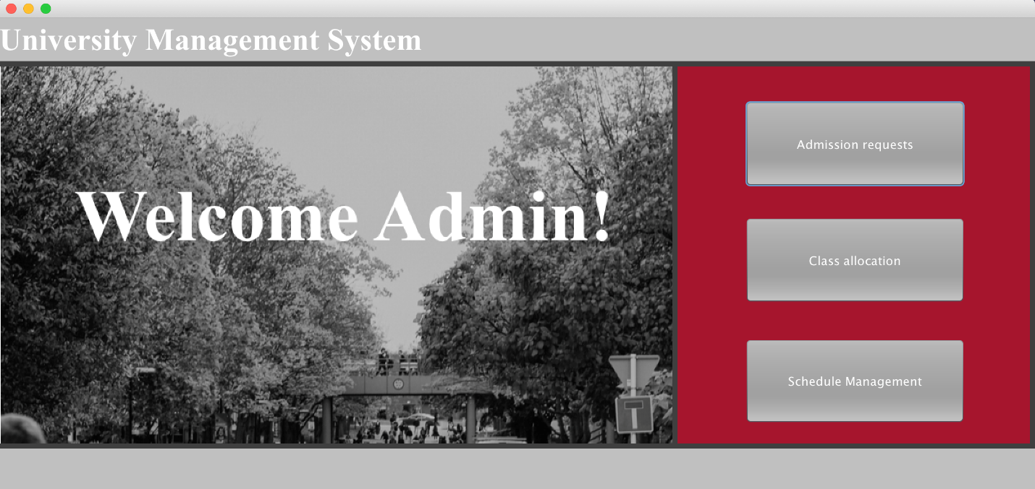

#### Figure 27: Student Affairs HomePage

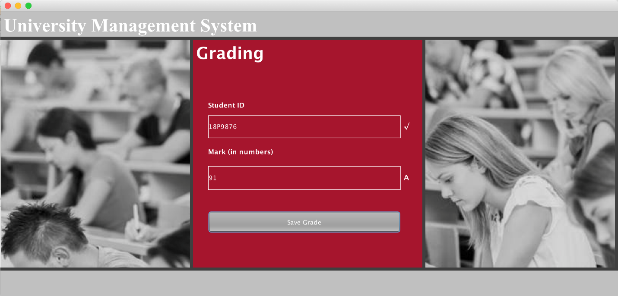

#### Figure 28: Grading GUI

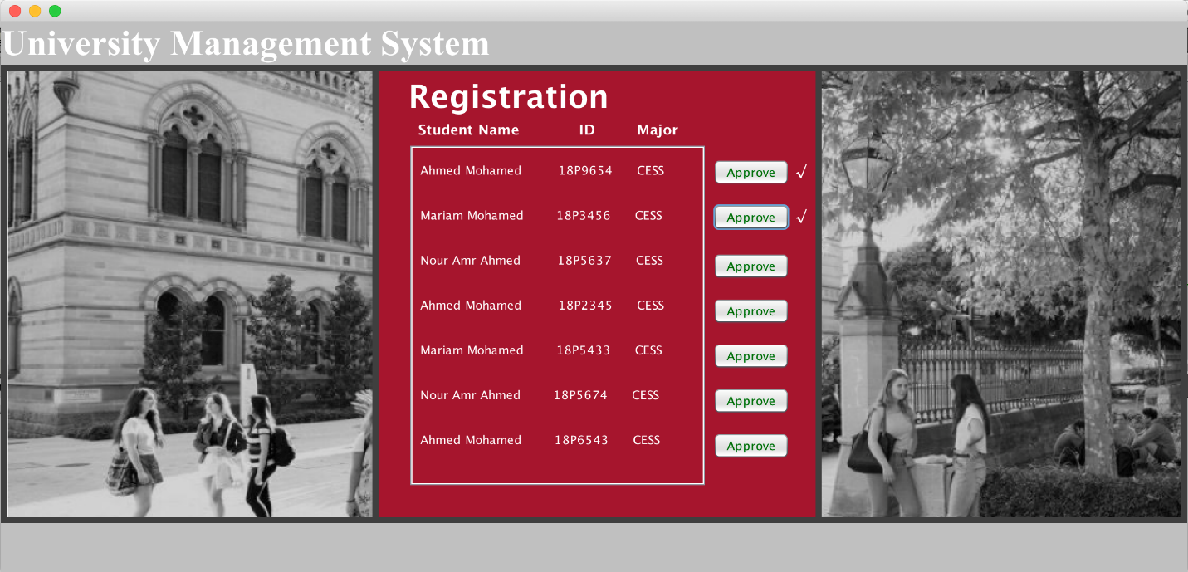

#### Figure 29: Registration GUI

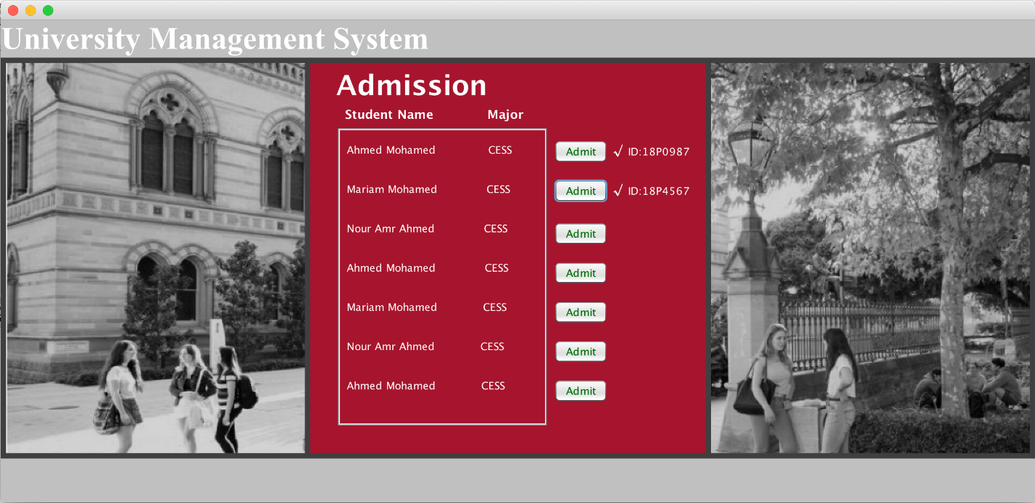

#### Figure 30: Admission GUI

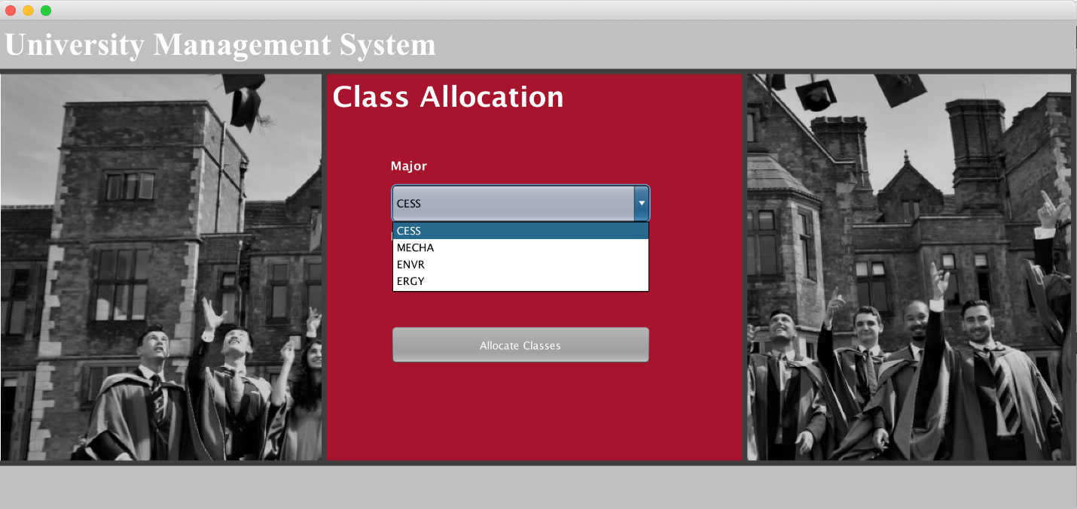

#### Figure 31: Major Selection in Class Allocation

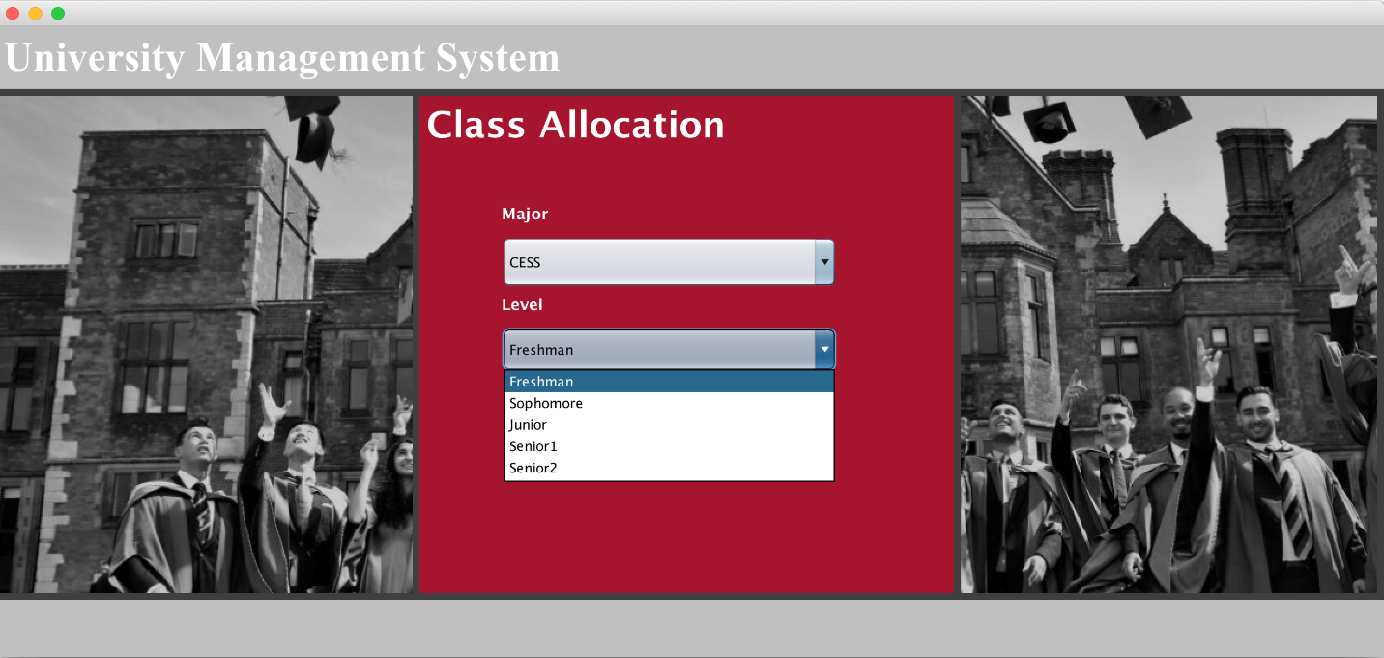

#### Figure 32: Level Selection in Class Allocation

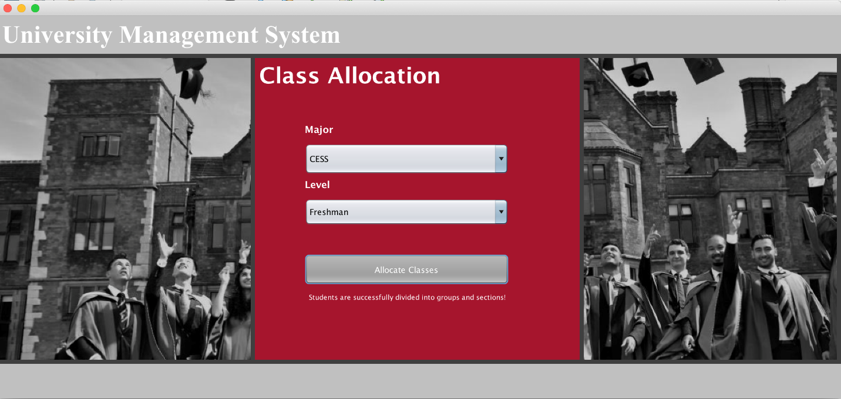

#### Figure 33: Class Allocation GUI

# Appendices

???